Full Stack Development with MERN
DocSpot: Seamless Appointment Booking for Health
Team Members:
Purella Manohar (Team Lead) -Backend Development
Ajay Roshan Didde -FrontEnd Development
Bandi Poorna Sri Sailaja -Integration and Documentation
Anudeepika Gubbala -Backend Development

Introduction
In today’s fast-paced digital world, accessing healthcare services efficiently has become a necessity. Traditional appointment booking methods often involve long waiting times, manual scheduling errors, and difficulty in managing patient records. To address these challenges, DocSpot: Seamless Appointment Booking for Health is developed as a full-stack web application using the MERN stack (MongoDB, Express.js, React.js, and Node.js).
DocSpot provides a centralized and user-friendly platform where patients can easily browse doctors, book appointments, upload medical documents, and track appointment statuses in real time. The system also enables doctors to manage their schedules efficiently and allows administrators to monitor and control overall platform operations.
The application follows a client-server architecture, ensuring smooth communication between the frontend and backend through RESTful APIs. With secure authentication and role-based access control, the system ensures data privacy and authorized access for patients, doctors, and administrators.
The primary objective of this project is to digitalize and simplify the healthcare appointment booking process, making it more accessible, reliable, and efficient for all users.

Project Overview
Purpose:
The purpose of DocSpot is to provide a digital solution for managing doctor appointments efficiently and securely. Traditional appointment booking methods often involve manual processes, long waiting times, scheduling conflicts, and lack of transparency. This project eliminates these inefficiencies by offering an automated, user-friendly, and centralized webbased platform.
The goals of the project are:
- To simplify the appointment booking process for patients
- To provide doctors with an organized system to manage schedules
- To enable administrators to monitor and control platform activities
- To ensure secure authentication and role-based access control
- To provide real-time updates on appointment status
- To create a scalable and maintainable healthcare management system using the MERN stack
Features:
Patient Features
- User registration and login with secure authentication
- Browse and view available doctors
- Filter doctors based on specialization and availability
- Book appointments by selecting date and time
- Receive confirmation and status updates
- View booking history
Doctor Features
- Register and apply for doctor account
- Await admin approval
- View appointment requests
- Confirm or cancel appointments
- Manage schedule and update appointment status
- Update consultation details
Admin Features
- Monitor overall platform activities
- Approve or reject doctor applications
- Manage users and doctors
- Maintain system integrity
- Handle operational issues
Technical Features
- RESTful API communication
- JWT-based authentication
- Secure password hashing using bcrypt
- MongoDB for scalable data storage
- Responsive UI using React, Bootstrap, and Material UI
- Dynamic data updates without page reload

Architecture
The application follows a Client-Server Architecture using the MERN stack.

Frontend Architecture
The frontend is developed using React.js with a component-based architecture.
Architecture Design
- Reusable components such as Navbar, Forms, Dashboards, and Appointment Cards
- React Router for navigation
- Axios for API communication
- Bootstrap and Material UI for responsive design
- Role-based dashboard rendering
Frontend Flow
User Interaction → Axios API Call → Backend Processing → Response → UI Update
Key Frontend Modules
- Authentication Pages
- User Dashboard
- Doctor Dashboard
- Admin Panel
- Appointment Booking Form
- Booking History Page

Backend Architecture
The backend is built using Node.js and Express.js following the MVC pattern.
Structure
- Routes – API endpoints
- Controllers – Business logic
- Models – Database schemas
- Middleware – Authentication and authorization
Backend Flow
Client Request → Route → JWT Middleware → Controller → Database → Response
Backend Features
- RESTful APIs
- JWT authentication
- Password hashing
- Role-based authorization
- Error handling middleware
- File upload handling

Database Architecture
MongoDB is used as the database with Mongoose as ODM.
Users Collection
Fields:
- _id
- name
- email
- phn_num
- password (hashed)
- timestamps Doctors Collection
Fields:
- userId
- specialization
- experience
- availability
- status
- timestamps Appointments Collection
Fields:
- userId
- doctorId
- appointmentDate
- appointmentTime
- status
- documents
- timestamps
MongoDB ensures scalability, flexible schema design, and efficient data retrieval.

Setup Instructions

Prerequisites

1. Software Requirements
- Node.js (v16 or higher)
- npm (comes with Node.js)
- MongoDB Atlas account (for cloud database connection)
- Git (for cloning the repository)
- Code Editor (e.g., VS Code)

2. Optional Tools
- Postman (for API testing)
- MongoDB Compass (for database visualization)

Installation

Step 1: Clone the Repository
Open terminal or command prompt and run:

git clone <repository-link>
Navigate into the project directory:

cd docspot
Step 2: Install Backend Dependencies Navigate to the server folder:

cd server
Install required dependencies:
npm install

Step 3: Configure Environment Variables
Inside the server folder, create a _{.env} file and add the following:
PORT=5000
MONGO_URI=your_mongodb_connection_string
JWT_SECRET=your_secret_key Replace:
- your_mongodb_connection_string with your MongoDB Atlas connection string.
- your_secret_key with a secure random string.

Step 4: Install Frontend Dependencies
Open a new terminal and navigate to the client folder: cd client
Install frontend dependencies:
npm install
Step 5: Start the Application Start Backend Server:
cd server npm start
Backend runs on: http://localhost:5000
Start Frontend Application:
cd client npm start
Frontend runs on: http://localhost:3000
After completing these steps, the application will be successfully running on your local system.

Folder Structure

Client Folder Structure
docspot/
client/ │
├── public/
│ └── index.html
│
├── src/
│ ├── components/
│ ├── pages/
│ ├── redux/ (or context/)
│ ├── hooks/ │ ├── utils/
│ ├── assets/
│ ├── App.js
│ └── index.js

│ └── package.json Server Folder Structure
server/ │
├── config/
├── controllers/
├── models/ ├── routes/
├── middleware/
├── utils/
├── uploads/ (if file upload is used)
├── server.js
└── package.json

Running the Application
Starting the Backend Server
- Open a terminal.
- Navigate to the server directory:
cd docspot
cd server
- Start the backend server:
npm start
If configured correctly, the backend will run on:

http://localhost:5000
Starting the Frontend Server
- Open a new terminal window.
- Navigate to the client directory:
cd docspot
cd client
- Start the React application:

npm start
The frontend application will run on:
http://localhost:3000

API Documentation
Base URL: http://localhost:5000/api
Authentication APIs
User registration and login with JWT token generation
Doctor APIs
Doctor application, listing approved doctors, admin approval
Appointment APIs
Book appointment, get appointments, update appointment status
Admin APIs
View and manage doctor applications
All protected routes require Authorization: Bearer <JWT_TOKEN>

Authentication
Authentication is implemented using JWT and bcrypt.
- Passwords are hashed before storing
- JWT generated on login
- Token stored on client side
- Token attached to request headers
- Middleware verifies token
- Role-based access control enforced
Security measures include:
- Encrypted passwords
- Secure JWT signing
- Environment variable protection
- HTTP 401/403 for unauthorized access

User Interface
The UI is responsive, modern, and role-based.
Includes:
- Login Page
- Registration Page
- Patient Dashboard
- Appointment Booking Form
- Booking History
- Doctor Dashboard
- Admin Panel
Designed using React, Bootstrap, and Material UI.

Testing
Manual and functional testing was performed.

Frontend Testing
- Form validation
- Navigation testing
- Role-based rendering
- Appointment workflow Backend Testing
- API response validation
- JWT verification
- CRUD operations
- Error handling

Database Testing
- Data storage validation
- Password hashing verification
- Relationship consistency

Integration Testing
- Axios API communication
- Real-time UI updates
- Data consistency
All core functionalities were validated successfully.

Screenshots

Login Page
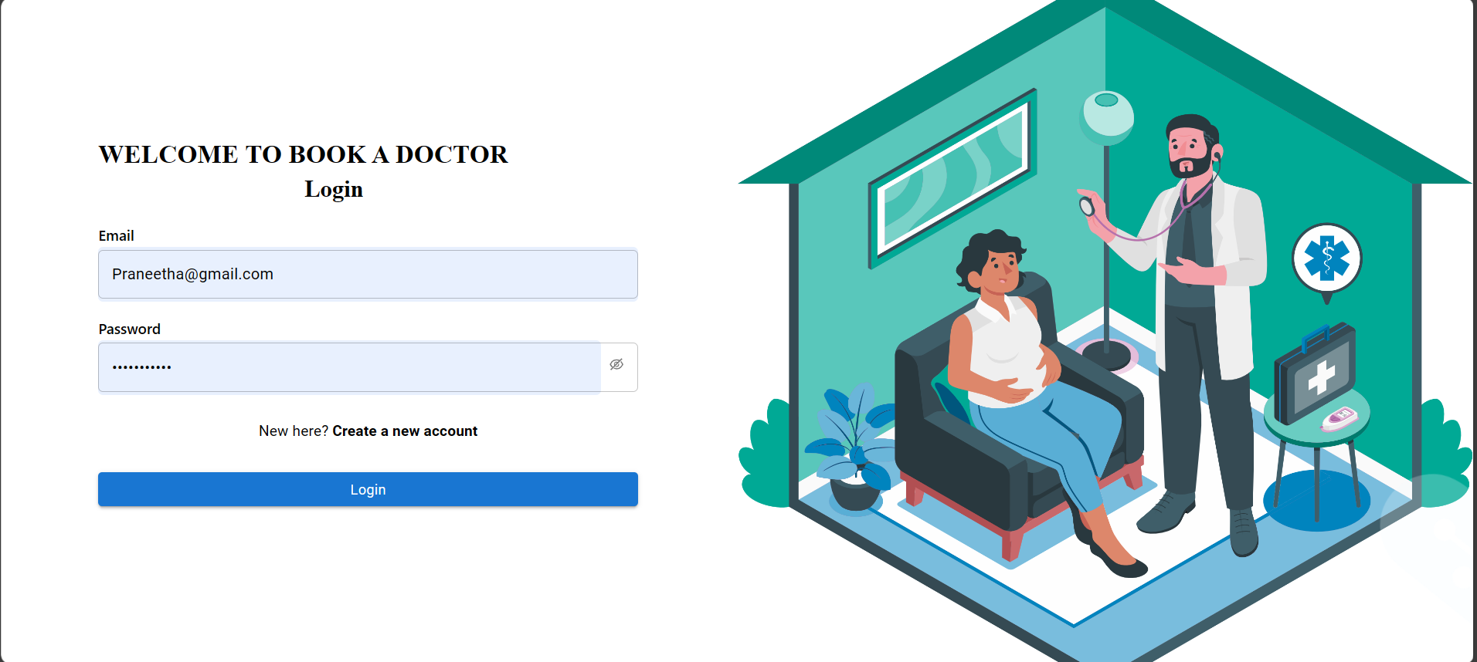

Registration Page
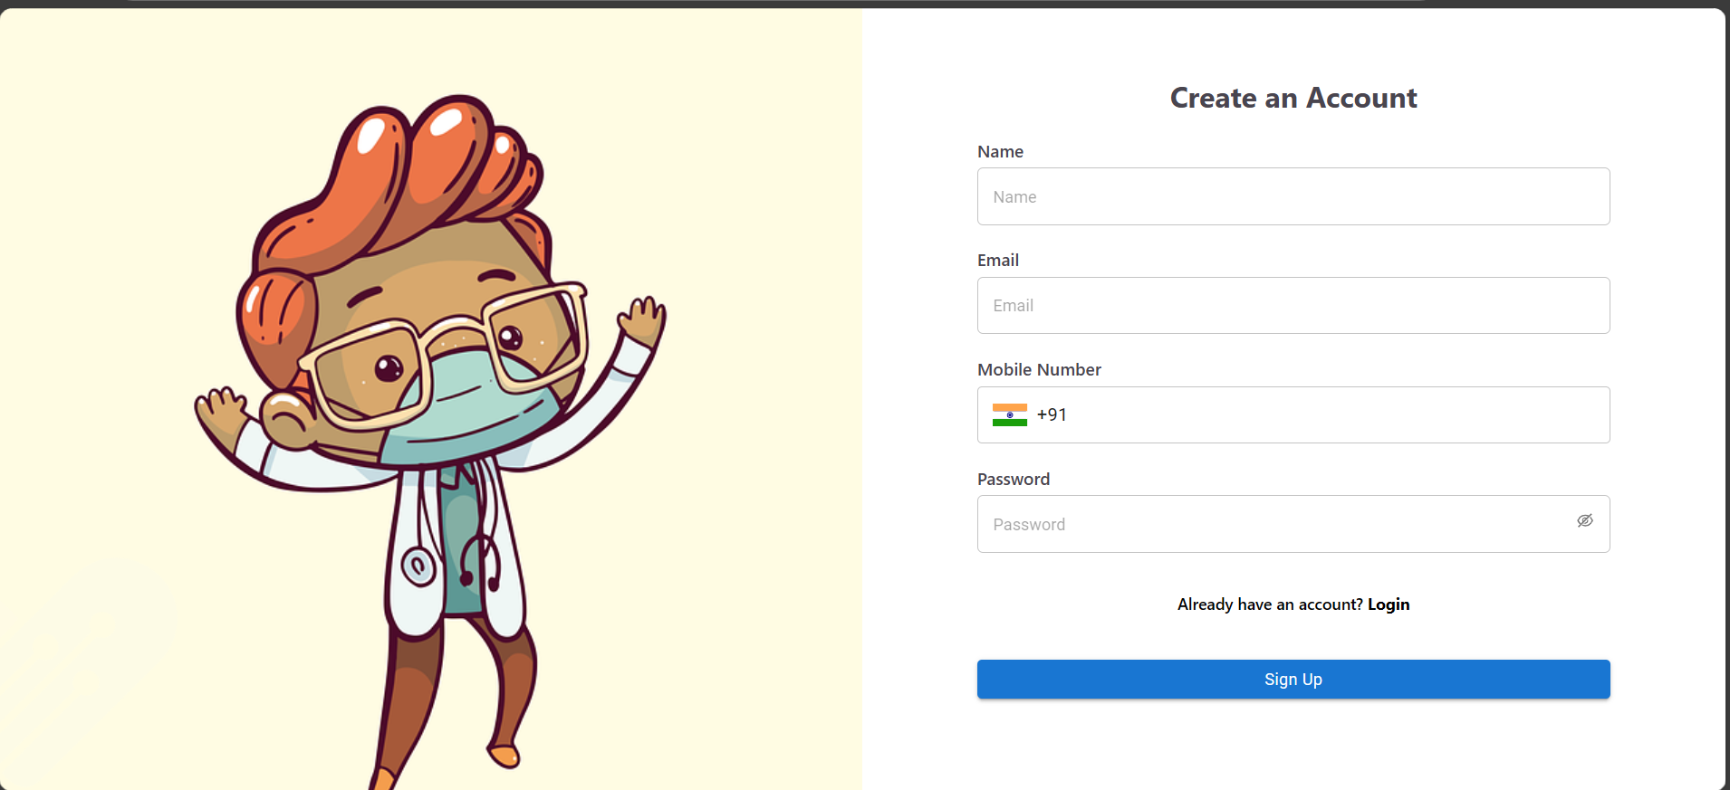

Patient Dashboard
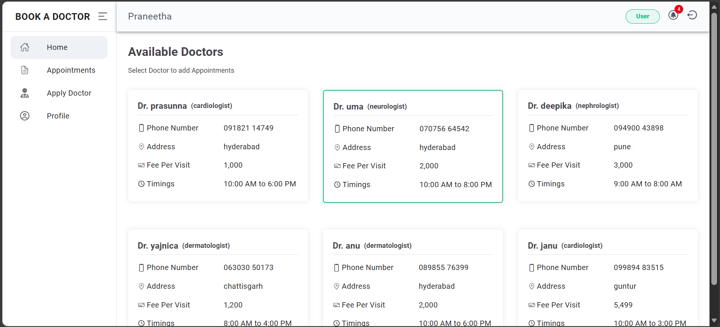
Appointment Booking
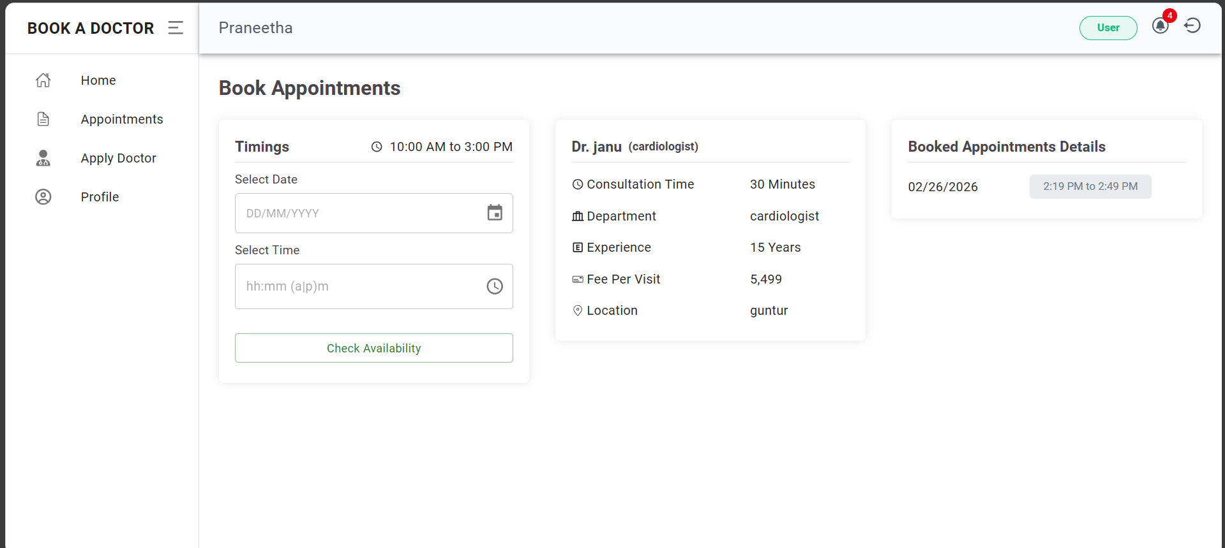
Booking History
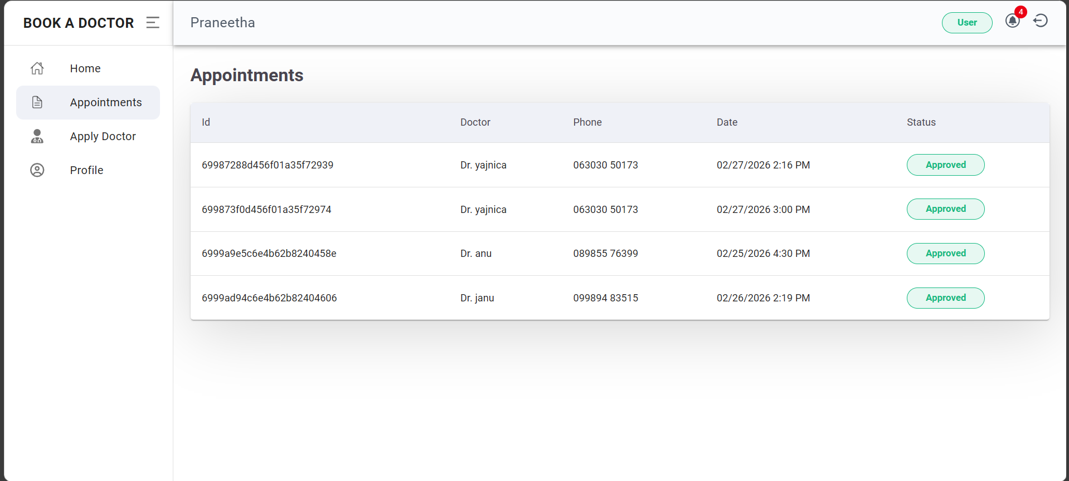

Doctor Dashboard
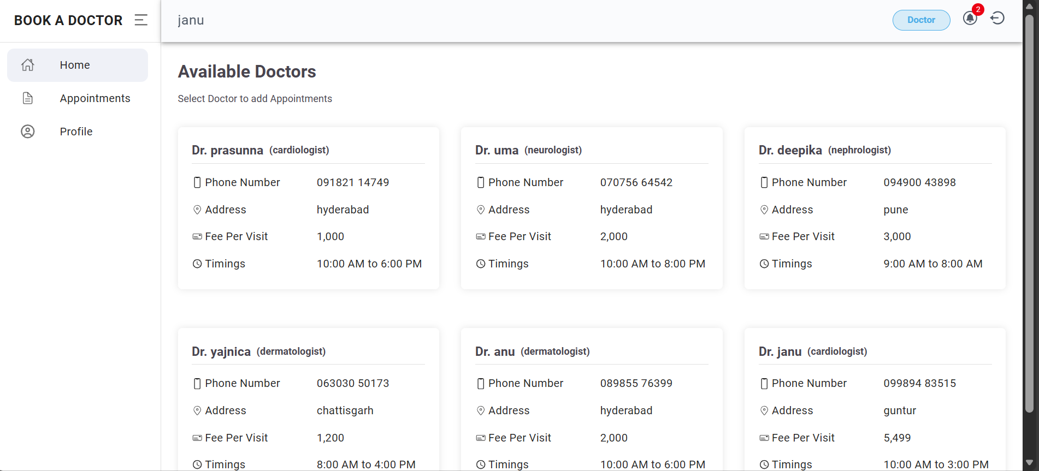
Doctor can Approve or Reject the Appointments
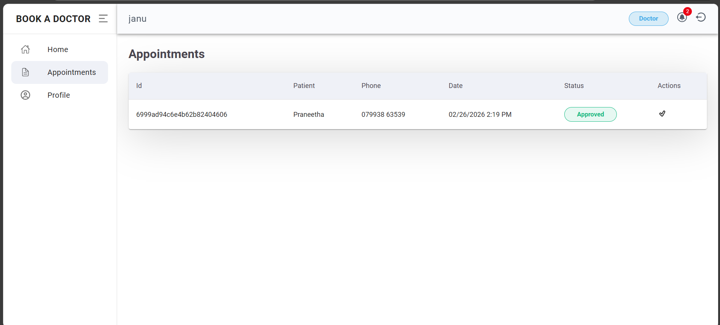
Admin Panel
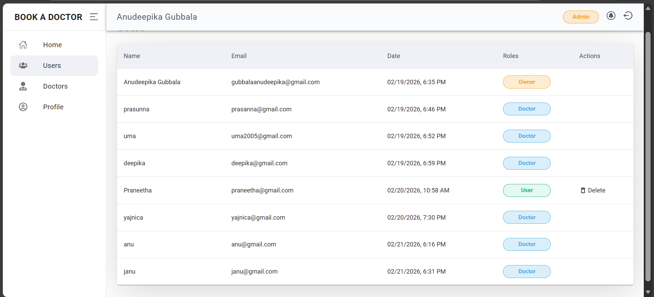
Doctors can Approve or Block the Doctor
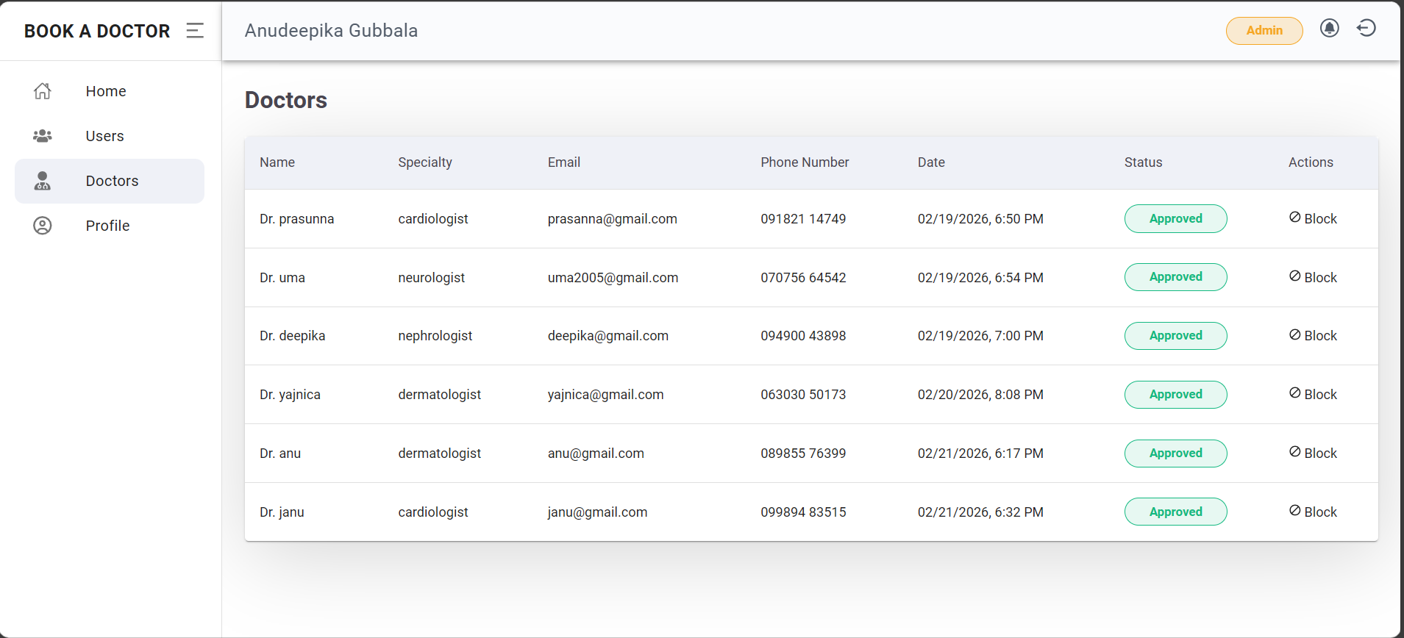

Known Issues

No Real-Time Push Notifications
The system currently does not support real-time push notifications. Users must manually check their dashboard to view appointment updates such as confirmation, cancellation, or rescheduling. Instant notification mechanisms like WebSockets or push services are not implemented.

No Email or SMS Alerts
Appointment confirmations, reminders, and status updates are not sent via email or SMS. All notifications are limited to in-application updates, which may reduce communication effectiveness if users do not log in frequently.

No Online Payment Integration
The platform does not include payment gateway integration. Patients cannot pay consultation fees online during the booking process, and payments must be handled offline at the clinic.

Basic Error Messages
Some backend validation and system errors return generic messages. More descriptive and user-friendly error handling could improve user experience and debugging clarity.

No Load Balancing or Caching
The application does not implement advanced performance optimization techniques such as load balancing or caching. Under heavy user traffic, performance may degrade due to lack of scalability mechanisms.

Manual Testing Only
The project relies solely on manual testing. Automated testing frameworks such as Jest, Mocha, or integration testing tools have not been implemented, which may limit long-term maintainability and regression testing efficiency.

No Token Refresh Mechanism
JWT authentication is implemented without refresh tokens. When a token expires, users are required to log in again manually, which may interrupt the user experience.

Limited File Validation
If document upload functionality is used, file validation is basic. Advanced validation such as strict file type checking, file size limits, and secure cloud storage integration is not fully implemented.

Minor Mobile UI Adjustments Needed
Although the application is responsive, certain layouts and spacing elements may require further optimization for smaller screen devices to improve visual alignment and user interaction on mobile platforms.

Future Enhancements

Online Payment Integration
Integrate secure payment gateways (e.g., credit/debit cards, UPI, net banking) to allow patients to pay consultation fees online during appointment booking.
Benefits:
- Reduces no-shows
- Provides secure transaction records
- Improves convenience for users

Email and SMS Notifications
Implement automated notifications for:
- Appointment confirmation
- Reminder before appointment
- Cancellation updates
- Doctor approval status
This can be achieved using services like email APIs or SMS gateways.

Video Consultation Feature
Add telemedicine support through:
- Video calling integration
- Secure online consultation rooms
- Digital prescription sharing
This would enable remote healthcare access.
Rating and Review System Allow patients to:
- Rate doctors
- Provide feedback
- View reviews before booking
This improves transparency and trust.

Advanced Filtering and Search
Enhance doctor search functionality by adding:
- Location-based filtering
- Availability calendar view • Experience-based filtering
- Fee range filtering

Admin Analytics Dashboard
Develop a detailed analytics panel for administrators showing:
- Number of active users
- Appointment statistics
- Doctor performance metrics
- Monthly booking trends

Mobile Application
Develop a cross-platform mobile application using:
• React Native or Flutter
This would improve accessibility and user engagement.

Cloud File Storage Integration
Integrate cloud storage services for document uploads to:
- Improve scalability
- Enhance security
- Reduce server storage dependency Automated Testing Implementation Introduce automated testing using:
- Jest (Frontend testing)
- Mocha/Chai (Backend testing)
This would improve code reliability and maintainability.
Token Refresh Mechanism Implement refresh tokens to:
- Improve user session management
- Prevent frequent login interruptions
These enhancements would transform DocSpot into a more scalable, production-ready healthcare platform capable of handling large user bases and real-world medical service requirements.

